Secure Voice Chat Web Application
Megan Smith
Computer Science Department, Georgia State University
Atlanta, Georgia 30302 USA
msmith145@student.gsu.edu

Abstract— Applying security to audio data is still a major part of software security research. In order to add to that research, this paper will describe how I was able to produce a secure voice chat web-based application that allows multiple clients to broadcast audio messages to other clients in their browser. I performed encryption and decryption methods on audio messages by means of the RC4 stream cipher encryption algorithm. Encrypted audio messages are then sent to other users by accessing an ASP.NET SignalR hub. Users can authenticate other users by using the Authentication 4.0 Protocol, made available in the web application to be used at any time.

Keywords— audio data, security, RC4, encryption, decryption, ASP.NET, SignalR, Authentication 4.0 Protocol
- Summary
The main purpose of this project was to develop and implement a secure voice chat web-based application. The end goal being able to give multiple end users the functionality of audio communication through their web browser; two-way communication that is both reliable and, more importantly, secure. The main methods I used to produce this application include BLOB conversions, RC4 stream cipher, Authentication Protocol 4.0 and ASP.NET SignalR. The initial audio recorder is read as a BLOB file, which needed to be converted into a byte array in order to be encrypted and decrypted using RC4 stream cipher, and then converted into a WAV file in order to be played through the browsers media player. A synchronous connection between multiple users/clients was developed using ASP.NET SignalR and the interface in which these clients interacted with was built using JavaScript/JQuery, HTML, CSS and C#. Once a connection is started, either user has the ability to authenticate the other users using Authentication Protocol 4.0. If an authentication is failed, the client connection is immediately terminated. The results and conclusions from this project show a working web-based application that provides a secure environment for audio communication between authenticated users.

- Introduction
Before beginning the project, I first needed to acquire an audio recorder from the internet to be used as the main recorder and media player in the web application. I ultimately decided on the audio recorder found at this location:
https://webaudiodemos.appspot.com/AudioRecorder/index.html.

I made several modifications from this recorder versus the recorder that I ended up with in my final product. Mainly, I went through the code supplied with the free recorder and simplified it down so that I only used a small media player with a generic setup (play button, stop button, pause button, volume select and timing bar). To make a recording, all the user would need to do was hit the recorder button and hit the stop button to stop recording. I also left the feature of begin able to download your recording onto your computer. This download is available as at link located next to the media player of your recording. The code from the original recorder also provided a feature that allows the user to view a log for their recorder, a feature I maintain in my final project as well. This log shows the user when the audio recorder has been setup on their current browser, when the browser has gained access to use the computers microphone for the application, when the media stream has been created, when the recorder is initialised, when a recording session has begun and when a recording session has concluded. The log is housed at the bottom of the application screen.
When this recorder first obtains the recorder audio, it stores it in BLOB form. Before I could begin encrypting and decrypted the audio for my application, I first needed to convert the audio to a byte array. In order to do this I needed to understand the state of BLOB data. BLOB stands for Binary Large Object [1]. A BLOB is a collection of binary data stored as a single entity. It would make sense that the recorder would initially store the recording in this way since BLOBs are typically images, audio or other multimedia objects. Once I converted the BLOB into a byte array and did performed my encryption and decryption methods, I still need to convert the byte array into a WAV file format so the audio is compatible with the media player. This conversion to a WAV file put a slight limitation on my project in terms of the encryption method and wanting to be able to play the encrypted form of the audio. WAV files have a very specific file structure. Figure 1 depicts the file structure for a basic WAV file [2]. The first chunk (the purple chunk from Figure 1) shows that the first four bytes of a WAV file should be “RIFF”, the next four bytes indicates the size of the file and then “WAVE”. The second chunk (in green) starts with “fmt” with an empty byte at the end, then come four bytes showing the length of “fmt”, followed by audio format, number of channels, sample rate, byte rate, block align and bits per sample. The third chunk (in orange) is where the actual audio data is stored, this is the part we actually care about in terms of security. The first four bytes of the third chunk is the name of the chunk, “data”. Then the next four bytes indicate the size of the data, followed by the samples themselves.

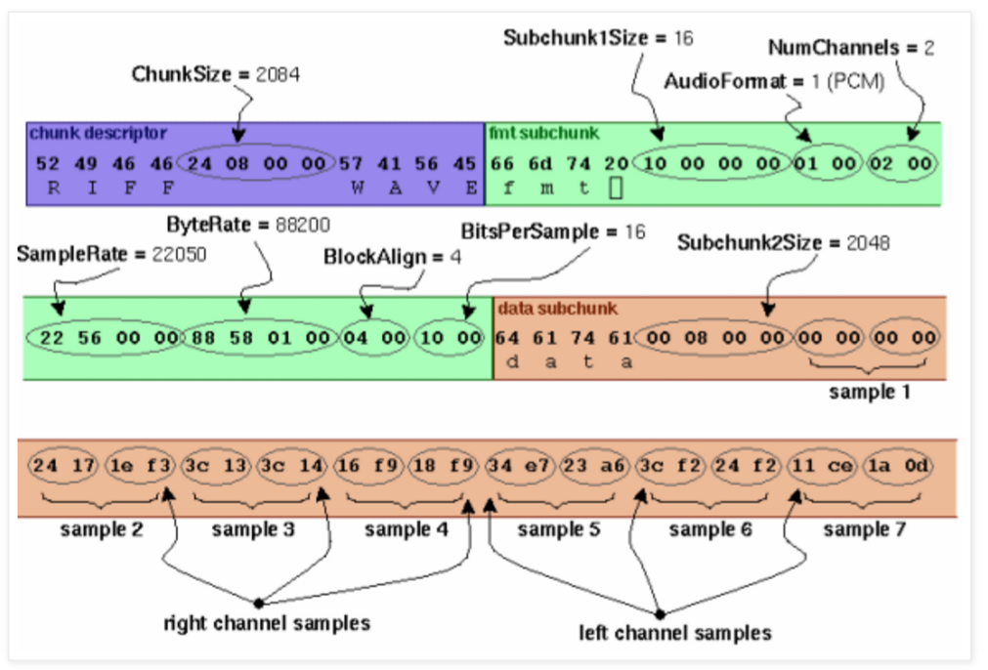

Figure 1: WAV file structure

Before understanding the WAV file structure, encrypting the entire audio file and then attempting to play the encrypted audio (which would sound like inaudible static) resulted in the error, “This type of audio format cannot be played”, from the media player. This error occurred because I was encrypting the part of the WAV file that defined it as a WAV file format, these identifying section is the first 44 bytes of a WAV file. To remedy this error, I left the first 44 bytes of every audio file alone, and proceeded to encrypt and decrypt only the audio data itself, essentially everything byte after the first 44 bytes of the WAV file. After applying this fix, I was able to encrypt the audio and play the encrypted audio (heard as static) using the media player.
I used the RC4 stream cipher encryption method to encrypt and decrypt the audio data. I performed all encryption and decryption on a converted version of the audio data, converted to the form of a byte array. With all the data stored in a byte array fashion, using a synchronous stream cipher algorithm, such as RC4, made the most logical sense. Figure 2 shows the general functionality of the RC4 stream cipher algorithm. The algorithm is based on the use of a random permutation. A variable-length key from 1 to 256 bytes is initially created at the beginning of the RC4 stream cipher algorithm and set to a 256 byte vector S. S is initialized in ascending order, while a temporary vector, T, is also created. Where temporary vector, T, is also a vector of length 256. T is created by coping the key into T, byte by byte, for as many times as it takes to fill ass 256 bytes of vector T. If the key is exactly 256 bytes, then vector T is equal to that of the key in bytes. The following pseudocode simplifies the initialization procedure for vectors S and T of the RC4 stream cipher algorithm.
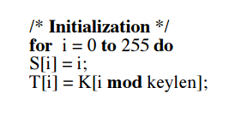
The next step of the RC4 algorithm produces the initial permutation of vector S by using vector T. this step involves starting by S[0] and going through to S[255], and for each S[i], swapping S[i] with another byte in S according to the value of j. Where the variable j is determined by a scheme dependent on T[i]. The pseudocode below shows the algorithmic step for the initial permutation of S.

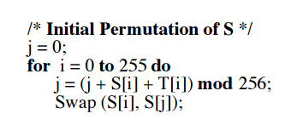

Next is the actual stream generation of the RC4 stream cipher encryption algorithm. Stream generation involves starting with the current version of vector S and going from S[0] through S[255]. For each S[i], swap S[i] with another byte in S, depicted as S[j] according to the current values of S[i] and S[j].this process continues until the entirety of vector S is swapped. This procedure for generating the key stream is shown in the pseudocode below.
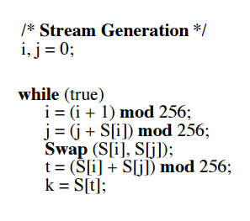
The last step in the RC4 stream cipher encryption algorithm is the actual encryption step. In order to encrypt the inputted data, XOR the plaintext with the final key stream generation. Visa versa, in order to decrypt encrypted data using the same key and RC4 stream cipher algorithm, XOR the ciphertext with the same key stream generation to produce the original plaintext. This algorithm is valid and secure because the only way to produce the same key stream generation in order to perform the decryption is by having the exact same key used to generate the key stream during the initial encryption process.

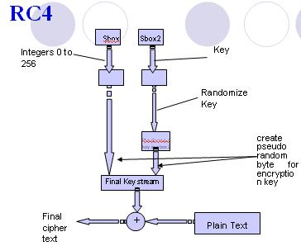

Figure 2: RC4 stream cipher algorithm setup

An additional functionality present in my project is the Authentication Protocol 4.0. Figure 3 show how protocol 4.0 works when Bob is attempting to authenticate Alice [4].

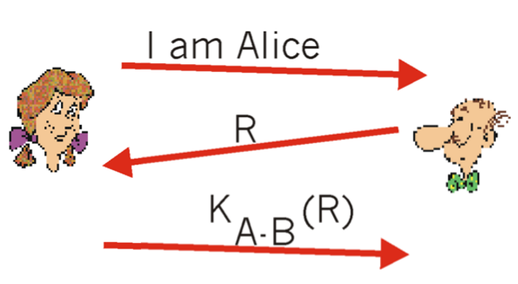
Figure 3: Authentication Protocol 4.0

The Authentication Protocol 4.0 is consider the no fail scenario, this effectiveness in security is the primary reason as to why I chose to use this protocol to perform the authentication in my project. Protocol 4.0 begins with Alice contacting Bob with the message, “I am Alice”. Bob then decides to first authenticate Alice before entering into a connection with her. Bob first sends Alice a nonce. A nonce is a number that a protocol will only ever use once in a lifetime. That is, once a protocol uses a nonce, it will never use that number again. In order for Alice to prove that she is an authenticated user, possessing the same shared secret key as Bob, she must continue to encrypt the nonce using the shared secret key and send the encrypted nonce back to Bob. It is the fact that Alice know the shared secret key between her and Bob and uses it to encrypt a value that lets Bob know that the message he receives was generated by Alice. The nonce is used to ensure that Alice is live. After Bob receives the encrypted nonce from Alice, he then decrypts the received message. If the decrypted nonce equals the once he sent Alice originally, then Alice is finally authenticated.
The final aspect of my project revolved around establishing the synchronous communication line between multiple clients for the audio chat to occur. In order to create this line of communication I used ASP.NETs SignalR [5]. SignalR is a server-side software system that makes developing real-time web functionality easy. SignalR allows bi-directional communication between server and client. Servers push content to connected clients instantly as it becomes available. SignalR provides both web sockets and hub functionality. For my project in particular, I utilized SignalR’s hub functionality. Web sockets is a protocol that allows asynchronous / full-duplex communication via the HTTP protocol. Hubs, which I will mainly focus on, allows multiple clients to connect through SignalR. When one client sends a message to the hub, it can be broadcasted to all clients that are connected to the hub. Essentially, the hub provides multicast functionality over web socket connections. Figure 4 shows a diagram that brings all the components of SignalR together in a representation of what the hosting environment would look like. In the figure, you see the IIS web server that is hosting a web application that implements SignalR. This web application contains the same necessary means for a client to establish a connection to the SignalR hub and, once connected to the hub, they can receive broadcasted messages sent from other clients and send messages to other clients as well.

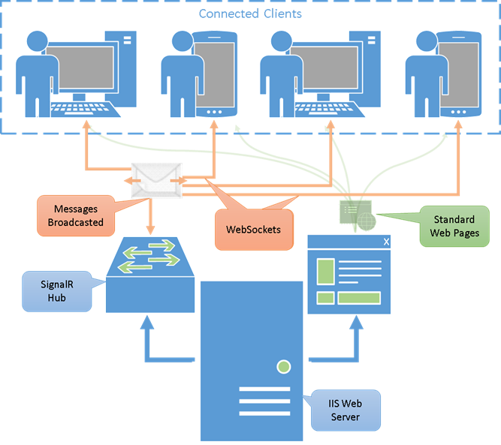

Figure 4: Structure of ASP.NET SignalR software

- Discussion
The main methodologies I used to develop the secure voice chat web application include implementing an audio recorder in the browser when the application is started, allowing the user/client to recorder an audio message that is intended to be broadcasted to an authenticated user, encrypting that audio message, broadcasting it in real time to the receiving party, decrypting the audio message on the receiving side and allowing the process to continue for however long the clients wish to keep communicating.
These methodologies can be narrowed down into three main project tasks, which are described below.

- Task one: Step one, use available audio recording software. As discussed in the introduction of this paper, I used a pre-existing audio recorder for the browser of my application. However, I made several simplifications to the software so as to use only what I needed for the scope of my secure voice chat application. Step two, convert BLOB into a byte array. To be specific, I converted the BLOB data into a Uint8Array type. In order to convert form BLOB to byte array however, I first had to read the BLOB data as an array buffer. Once I had my array buffer, I was then able to store it as a byte array of type Uint8Array. I then sent this byte array, which is the original recording of my client, to be encrypted by my RC4 stream cipher encryption algorithm. At this juncture, I also made a point to forward the encrypted audio to the code behind the front end of the web application so that it could be broadcasted to the receiving user through the SignalR hub. The encrypted audio is decrypted on the receiving end of the message. Step two, convert the decrypted byte array back into a WAV file. This is done by first converting the byte array into an array buffer again, and then reading the array buffer as a WAV audio file.

- Task two: Step one, used RC4 stream cipher algorithm to encrypt and decrypt each transmitted audio message. The code that I wrote to perform the RC4 stream cipher encryption in the audio data is show in Figure 5 below.

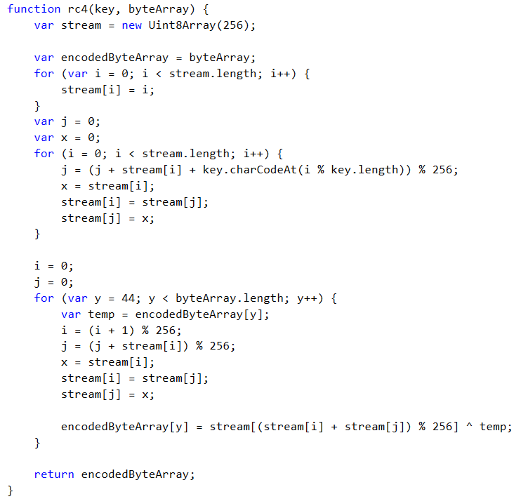

Figure 5: RC4 stream cipher encryption code

An important note to point out here is the final encryption step, where the key stream generation is XOR with the plaintext, doesn’t used the entirely of the plaintext. The encryption begin with byte 44 of the audio data. This reasoning was discussed in the introduction, begin that encryption done to the first 44 bytes of a WAV audio file will render the audio unplayable in the media player. Decrypting the encrypted audio is done on the receiving end of the message by calling the same RC4 method, where the decryption will only be successful if the user input the same shared secret key as the user who sent the encrypted message. Keep in mind that only encrypted audio is ever sent through the SignalR hub, for security reasons. Step two, use Authentication 4.0 protocol to verify users. Each user has the ability to perform the authentication at any time. The authentication code begins when a user presses the “Begin Authentication of User” button. For here a method for creating a nonce is called and that nonce is sent to the user needing to be authenticated. This user then hits the “Encrypt Nonce” button to encrypt the nonce on their end, with their shared secret key, and that encrypted nonce gets send back to the original user to be authenticated. The original user then selects the “Verify Nonce” button to decrypt the received encrypted nonce and verify the equality between that nonce and the nonce that was sent to the user being authenticated. If the nonce match, the user is authenticated. If the nonces do not match, the SignalR connection between the two clients is immediately broken. Figure 6 shows the communication that takes place between to clients using the Authentication 4.0 Protocol.

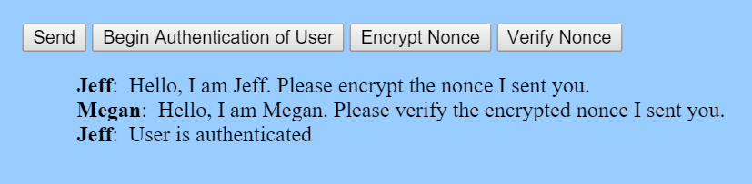

Figure 6: View of Authentication 4.0 Protocol

- Task three: Establish the platform for communication. This task is where the bulk of the code resided. Here I integrated SignalR and the audio recording software to work together so as to send the audio message through the SignalR hub. Figure 7 show the user interface, written in JavaScript, JQuery, HTML and CSS, that allows the clients to record their messages and view the broadcasted messages from other clients. In the figure you can see that the original recordings are stored in a list under the heading “Recordings” and the decrypted recording of the other clients sent messages and of the current users recordings are stored in a list under the heading “Decrypted Recordings”. The encrypted audio messages that are broadcasted over the SignalR hub are stored the blue box at the top of the web application. Next to each broadcasted message is the name of the user who sent the encrypted audio message. You can also so the user interface for recording an audio message, this interface came with the existing audio recording software. You can also see from the figure that each audio message (encrypted, decrypted or original recording) has a download link next to it. This functionality also came with the free audio recording software.

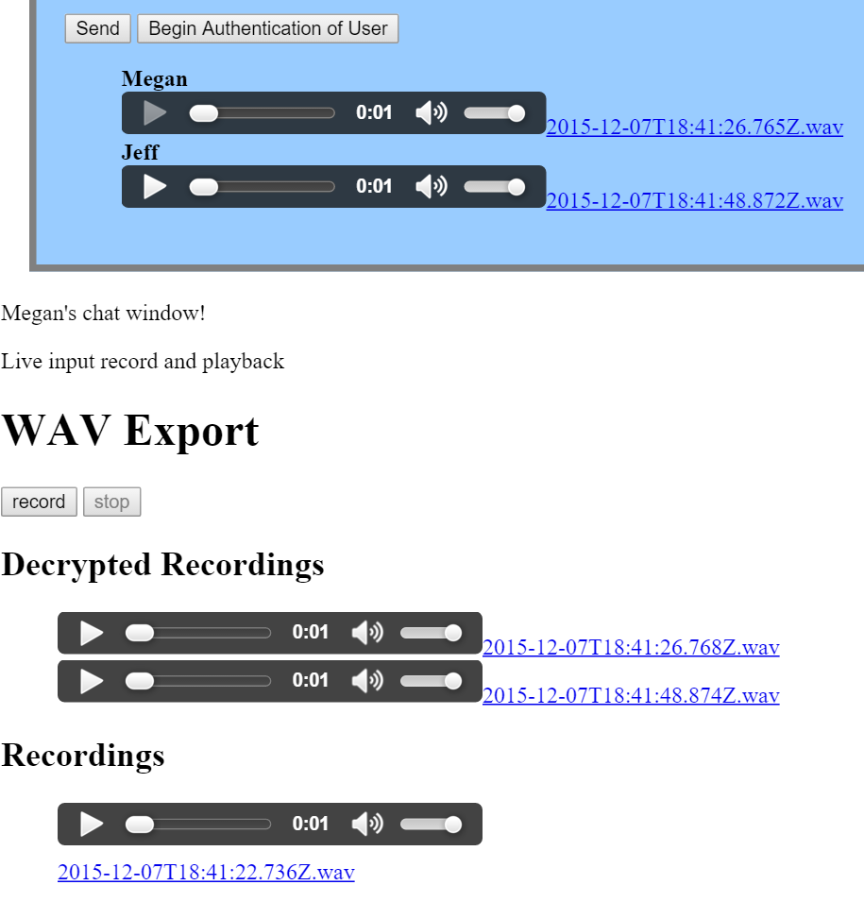

Figure 7: View of user interface

- results
The results from this project include a fully functional secure voice chat web application. A user is able to record as many audio messages as they want. They are also able to download these messages onto their home computer. Clients are able to send audio messages to other clients. Each audio message that is sent to a client is securely encrypted and successfully decrypted on the receiving end of the message. Users are also able to successfully perform user authentication at any time and as many times as they like. Over all, a secure environment for two-way voice communication was successfully implemented in the browser in the form of a web-based application.
- Conclusion
In conclusion, I used available audio recording software to recorder messages, encrypted and decrypted those audio message using RC4 stream cipher encryption algorithm, and sent those messages to other client by connecting the users using ASP.NET SignalR. I also provided further security to the working environment by allowing the users to authenticate each other by establishing Authentication 4.0 Protocol procedures in the web application.
- Recommendations
In the future, I wish to further develop this web application. Although the application itself is fully functional, this is the kind of project that can be continually improved upon. Making the user interface of the web application more colourful and professional looking would be one of the first additional tasks I would perform on this project. Also enquiring on to how many users can connect to the SignalR hub at a single time. Generally, I would also like to run some stress testing on the environment as well.
References
- "Binary Large Object." Wikipedia. Wikimedia Foundation. Web. 7 Dec. 2015. <https://en.wikipedia.org/wiki/Binary_large_object#cite_ref-1>.
- "Minimal." Structure Of *.wav Audio Files. Web. 7 Dec. 2015. <http://dracoater.blogspot.com/2008/11/comparing-2-audio-wav-files.html>.
- Stallings, William. "THE RC4 STREAM ENCRYPTION ALGORITHM" 2005. Web. 7 Dec. 2015. <http://chemistry47.com/PDFs/Cryptography/RC4 Stream Cipher/Tutorials/THE RC4 STREAM ENCRYPTION ALGORITHM.pdf>.
- Ross, Keith. "7.3 Authentication: Who Are You?" Authentication. 1999. Web. 7 Dec. 2015. <http://userpages.umbc.edu/~dgorin1/451/security/dcomm/authentication.htm>.
- Myers, Chris. "What Is SignalR: An Overview of Web Sockets and Hubs." Blogged By Chris. 31 Oct. 2013. Web. 7 Dec. 2015. <http://www.bloggedbychris.com/2013/10/31/signalr-overview-websockets-hubs/>.

